Caseload Report
Run the following Reports:
- Data Report Card
- Client Not Served (Supervisor Role)
- Legal Services Referral (Legal Services Role)
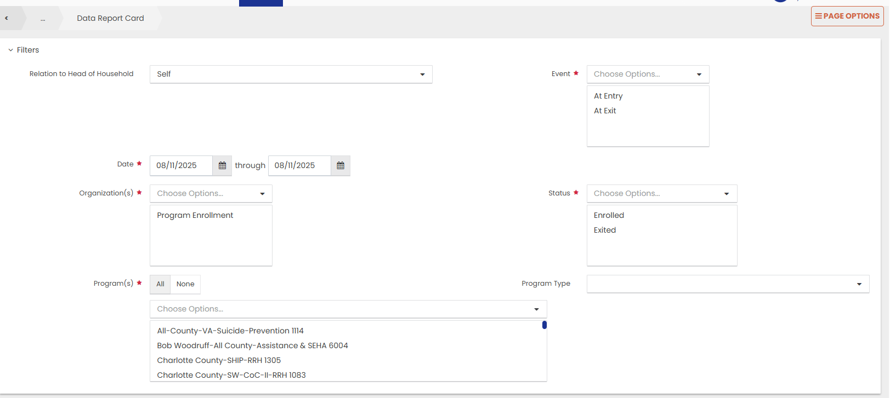
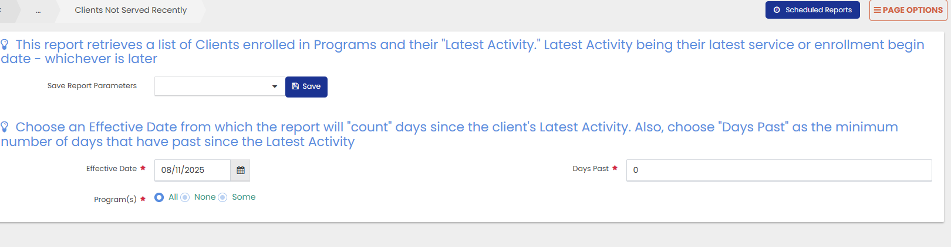
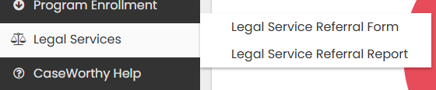
- Legal Services report: Filter for “Referred”

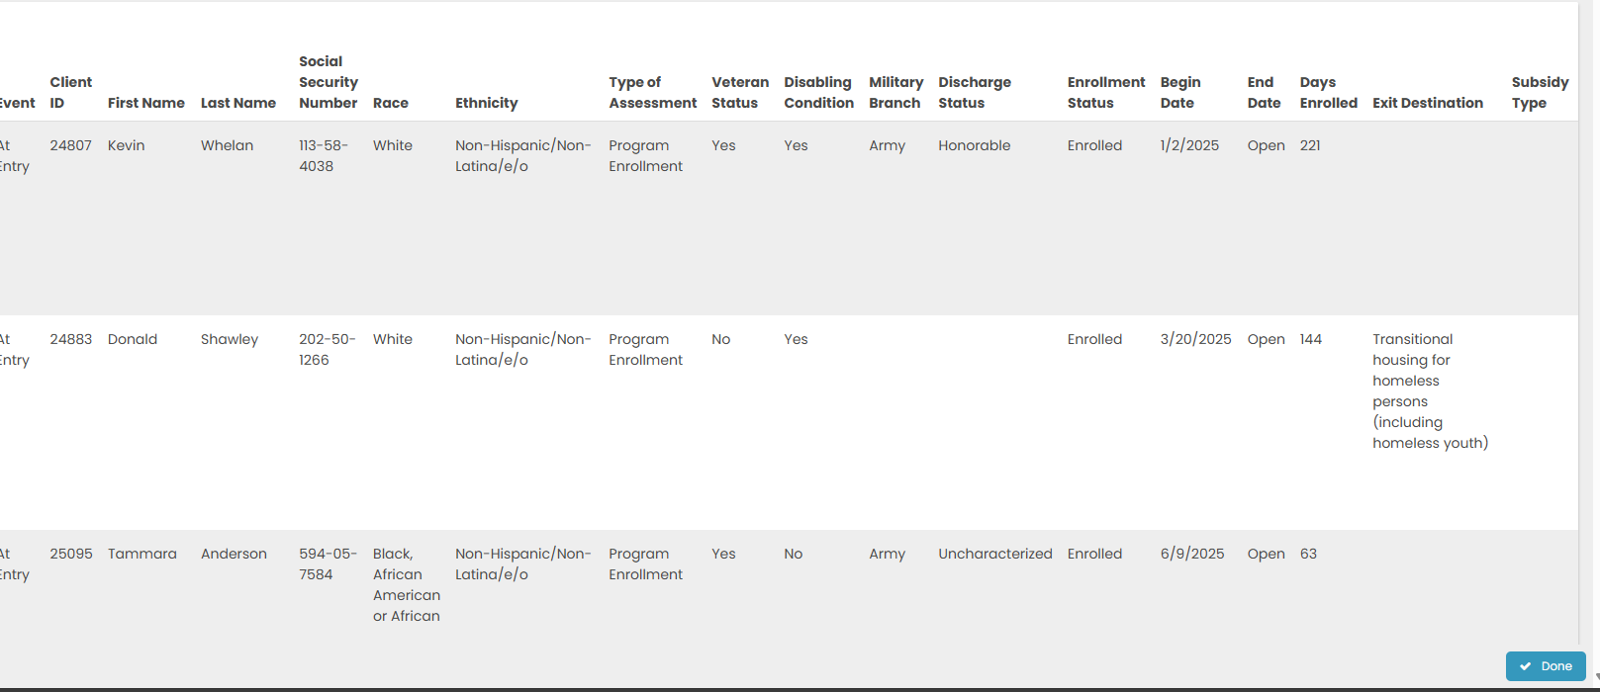
- Page Options >>Excel Report >> Open
- Delete all columns except the following:
  - Event
    - Ctrl F: Replace At Exit >> ZAT Exit
  - Client ID
  - First Name
  - Last Name
  - # Enrolled Family Members
  - Program Name
  - Begin Date
  - Days Enrolled
  - Move-In Date
  - Assigned Staff
  - Job Title: Replace Case Manager to “Z”
    - Column will be deleted after determining closed programs
  - Add column Date of Last Recertification
    - Formula: ‘=Today() – Days since Last Recert/Update’
    - =TODAY()-O2

  - Days since Last Recert/Update
  - Connection with SOAR
  - CurrentReceiveShallowSub
  - Referred from HUDVASH
  - Add column Received Legal Assistance
  - Add column Days With no Service/Contact
  - Add column Housed Not Housed
- Engage SORT
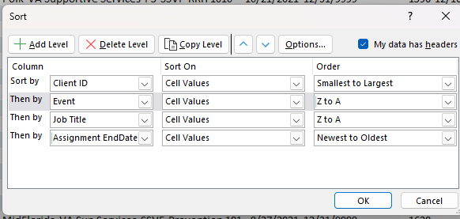
- Data >> Remove Duplicates >>
  - Click Client ID and Program Name
- Delete following columns
  - Event
  - Job Title
  - End Date
  - Assign Begin Date
  - Assign End Date
- Column: Last 90-day Recert: Formula: =Today() – Days since Last Recert/Update
  - Drag down
  - Copy and Paste as Number
- Engage Filter
  - Sort Program Name A-Z
  - Filter>>Text>>Does Not Contain>>ssvf
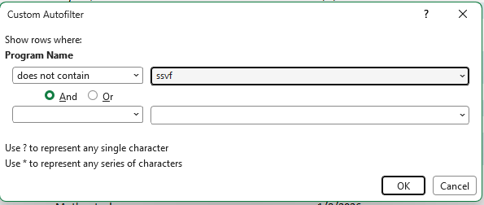
  - Columns: Current Receive Shallow, Referred from HUDVASH, Connection with SOAR
    - Replace with N/A
- Filter Program Names
  - All County VA 1114
  - Charlotte SHIP 1305
  - Tampa CDBG 1107
    - Columns: Last 90-Day Recert, Days since Last recert, Current Receive Shallow, Referred from HUDVASH, Connection with SOAR, Referred From HUD-VASH
      - Clean all rows
      - Remove Filters
- Column: Add Referred Legal Assistance
  - Formula: Received Legal Assistance - =VLOOKUP (A2, Sheet3!A:B, 2, FALSE)
- Column: Add Days with no Service/Contact
  - Formula: Days With No Service/contact - =INDEX (Sheet2!C:C, MATCH(1, (Sheet2!A:A=A2) * (Sheet2!B:B=E2), 0))
- Column: Add Housed/Not Housed
  - Formula: Housed/Not Housed - =IF(ISBLANK(H2), "Not Housed", "Housed")
- Column: Program Name
  - Filter for non-RRH programs
    - Column: Housed/Not Housed
      - Replace with N/A
- Sheet: Add Client not Served report as Sheet2
  - Unmerge the whole report
  - Delete rows 1 – 25
  - Unhide hidden/minimized columns
  - Delete all the blank columns and unnecessary columns
  - Columns: Leave only Client ID, Program Name, Day since Last Activity, Relationship to HoH
- Sheet: Add Legal Services Referral as Sheet3
  - Columns: leaving only CW Client ID and Referral Status
  - Convert CW client ID to Number Format
  - Filter Referral Status for “Approved”
  - Change “Referred” to “Received”
- Name Sheet1 as “All
- Sheet: Create and copy different tabs for the sites
- Copy “Format Painter” from previous reports and apply to rows.

